**DAILY ONLINE ACTIVITIES SUMMARY**

|  |  |  |  |  |  |  |  |  |
| --- | --- | --- | --- | --- | --- | --- | --- | --- |
| **Date:** | **26/05/2020** | | | | | **Name:** | **Shailashree** | |
| **Sem & Sec** | **IV sem & B section** | | | | | **USN:** | **4AL18CS077** | |
| **Online Test Summary** | | | | | | | | |
| **Subject** | | **Design and Analysis of Algorithms** | | | | | | |
| **Max. Marks** | | **30** | | **Score** | | | **25** | |
| **Certification Course Summary** | | | | | | | | |
| **Course** | **Introduction to Digital Marketing** | | | | | | | |
| **Certificate Provider** | | | **Greatlearning academy** | | **Duration** | | | **2.5 hours** |
| **Coding Challenges** | | | | | | | | |
| **Problem Statement1:** Given an array A of size N where the array elements contain values from 1 to N with duplicates, the task to find total number of subarrays which start and end with the same element.  **Problem Statement2:** Write a program in C to print all permutations of a given string using pointers. | | | | | | | | |
| **Status: Executed** | | | | | | | | |
| **Uploaded the report in Github** | | | | | **YES** | | | |
| **If yes Repository name** | | | | | **Online-coding** | | | |
| **Uploaded the report in slack** | | | | | **YES** | | | |

Online Test Summary: 18CS42 test was scheduled from 9:15 am t0 10:00am .The portion for the IA was 2nd module there were 30 questions and the time assigned was 45 minutes the questions were mcq type and some problems were given to solve.

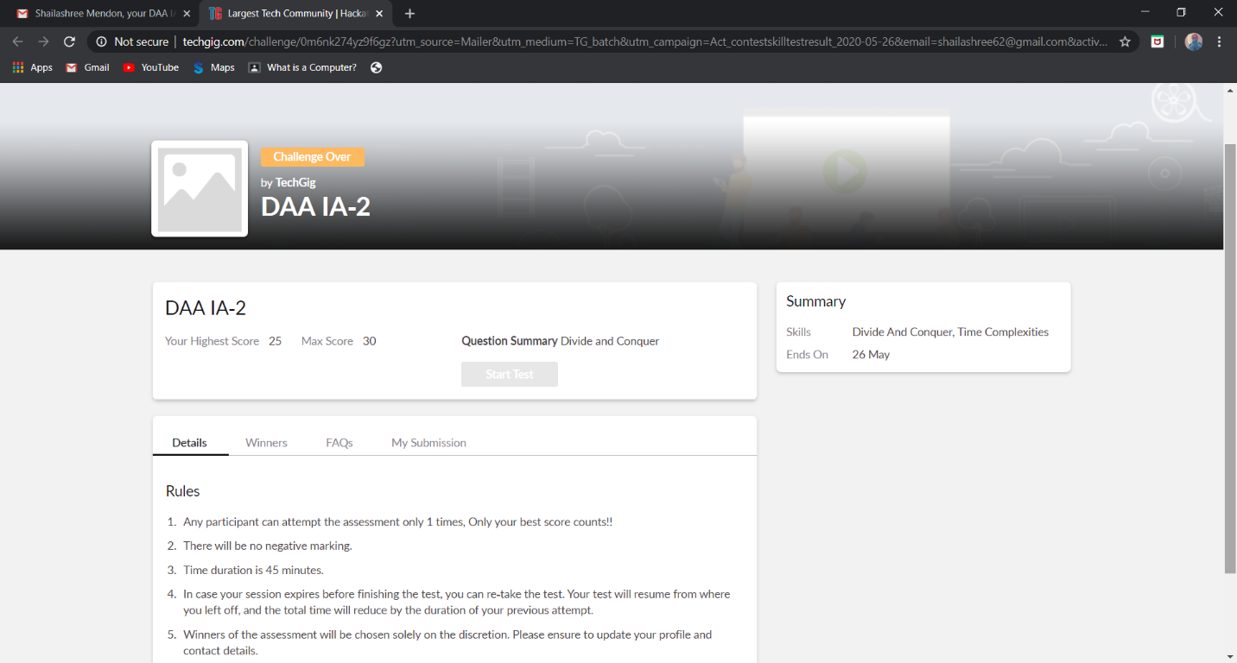

The above snap shot is the completion of the test and the marks allotted.

Online Certification Course Summary: Today I have learnt about Types of ads and completed the course. I have taken the Quiz and successfully passed it and also got my certificate.

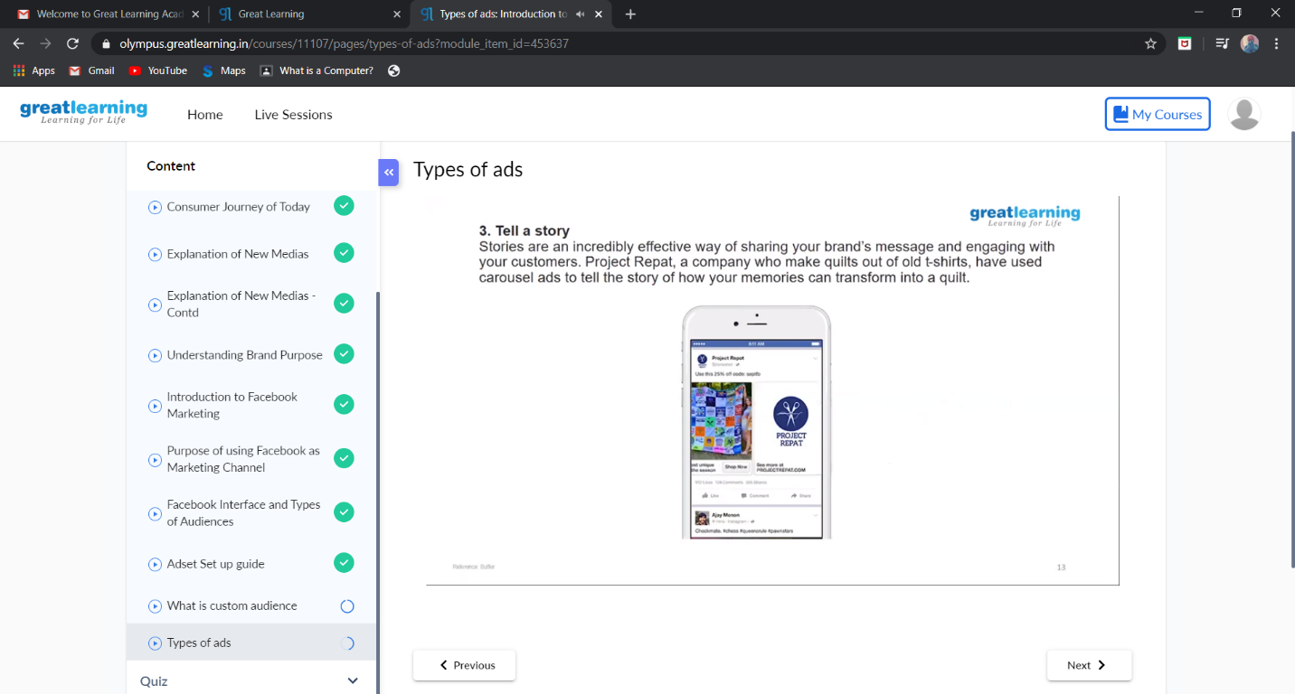

This is the snap shot of the last session that is where I learnt about types of ads in the Facebook.

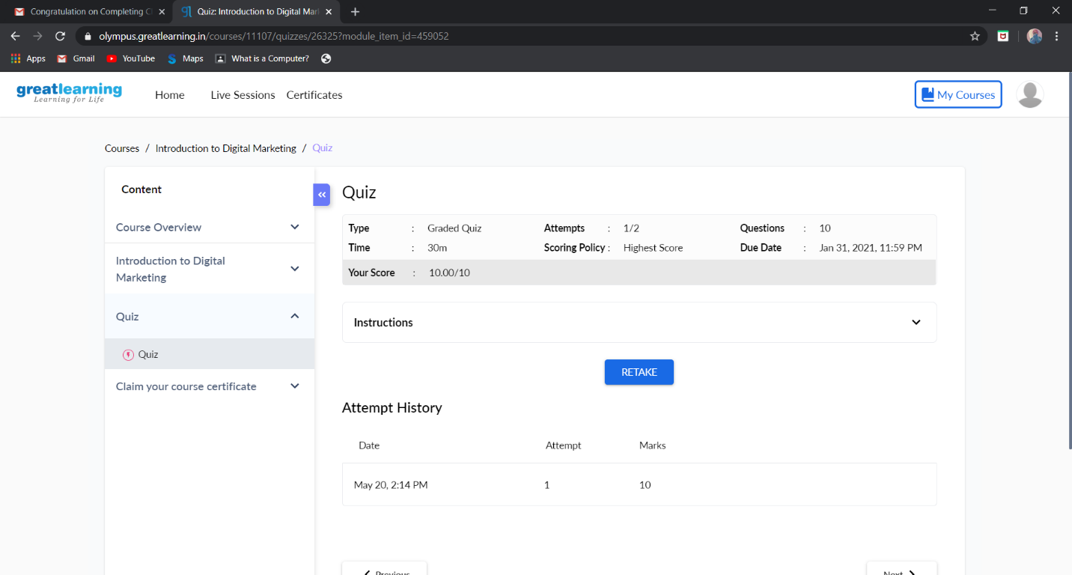

This is the snapshot of attending the quiz and grade obtained.

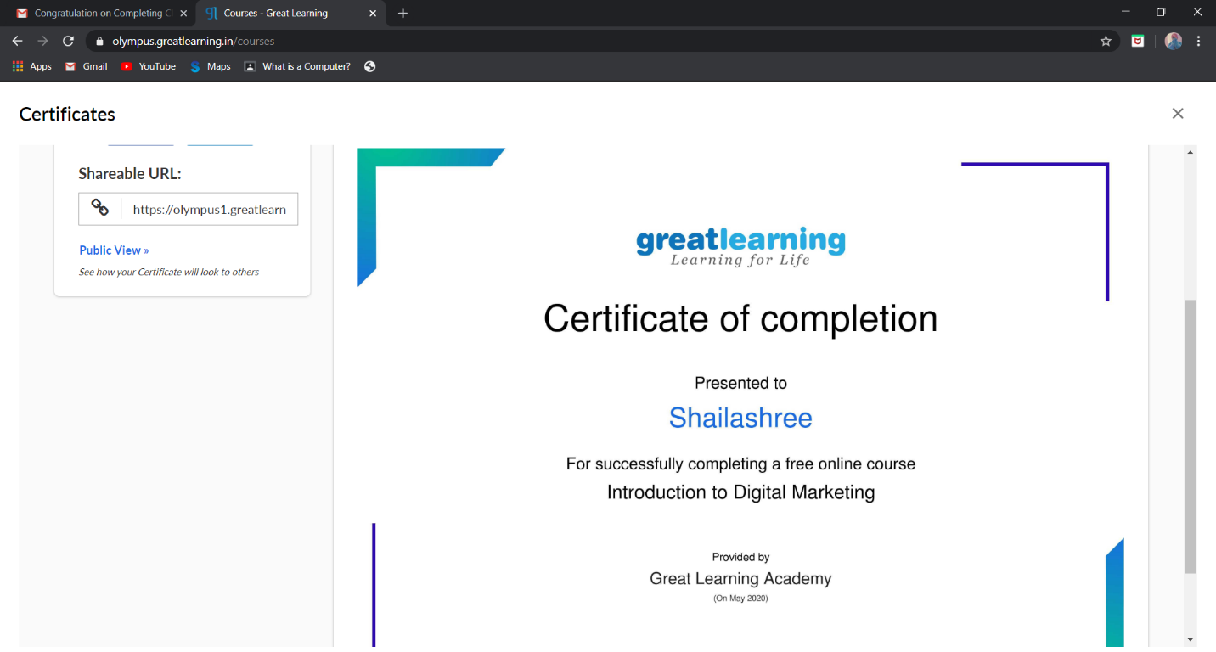

This the snapshot of certificate achieved after completion of the course.

Online Coding Summary: **Today I had received one program from prof.Vasudev CSE Dept and another from prof.Venkatesh CSE Dept. The programs is mentioned above in the coding challenges(pg.01). I have also uploaded it to my Github repository.**

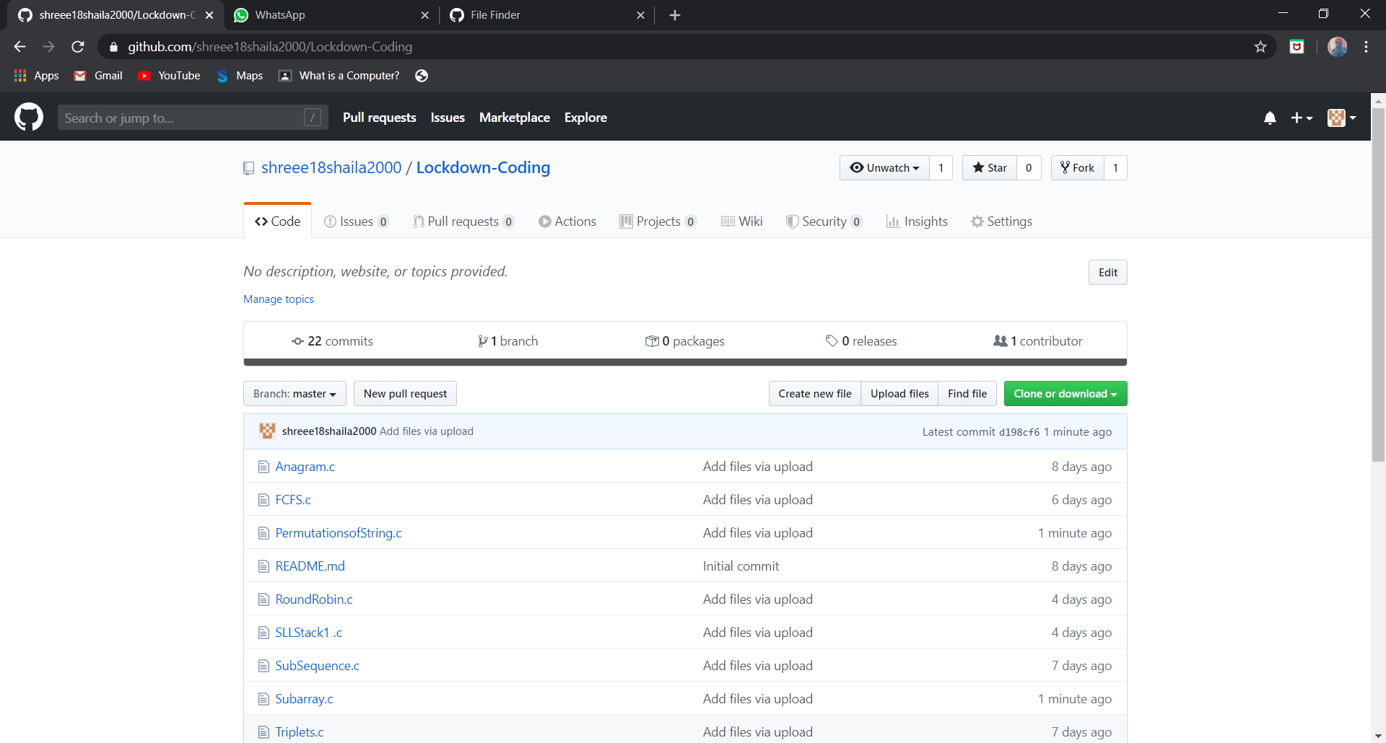

It is the snap shot of my repository were I have uploaded the code. File name is PermutationofString.c and subarrays.c